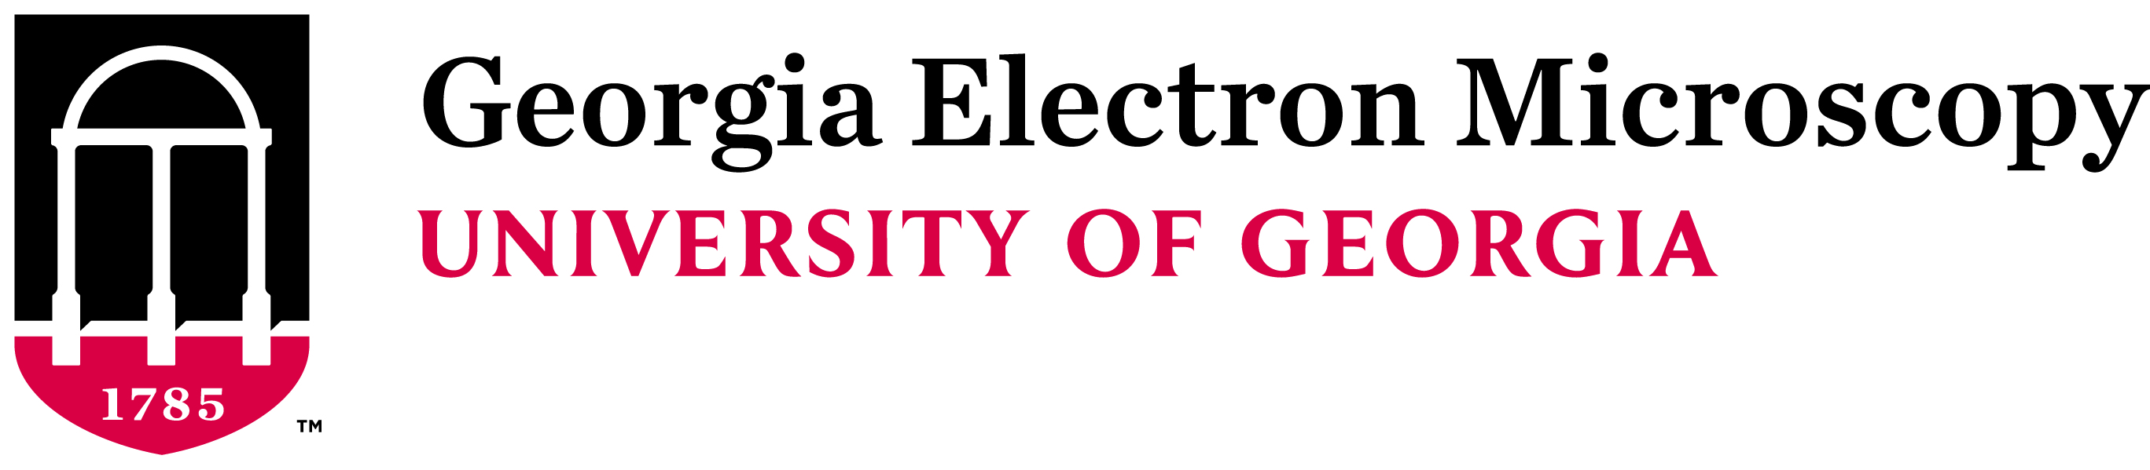
Biological TEM Workshop
This intensive, three-day workshop provides a practical and basic theoretical introduction to Transmission Electron Microscopy and biological sample preparation techniques. Each day will consist of lecture, discussion and hands-on training led by GEM staff.
Instructors: John Shields (jpshield@uga.edu)
Mary Ard (maryard@uga.edu)

Schedule
Session 1: Introduction and Sample Preparation

8:00 am Overview and introductions
8:30 am Begin prep from GA fixed and rinsed tissue (OsO4 Fix)
Laboratory Safety in an EM Lab
Lecture - Overview of Electron Microscopy
9:30 am Break
9:45 am Sample preparation (Rinse and dehydrate)
Discussion of Sample and Preparation
10:30 am Sample prep (Begin resin infiltration 25%)
11:00 am Sample prep (Resin infiltration 50%)
12:00 Lunch
1:00 pm Sample prep (Resin Infiltration 75%)
Lecture - Fixatives, buffers and dehydration
2:00 pm Sample prep (Exchange resin 100%)
2:30 pm Break
2:45 pm Sample Prep (Exchange resin 100%)
Semi-thick sections and demonstration (Ard)
3:45 Sample prep (Exchange resin 100%- leave overnight)
4:30 pm Lecture – Resins and Staining

Session 2: Electron Microscopy and TEM operation

8:00 am Overview of material covered
8:30 am Sample Prep (sample in molds, fresh resin and into oven)
Lecture – EM design and operation
9:00 am Hands on: Trimming blocks and glass knives
10:00 am Break
10:15 am Hands on: Practice knife making/block trimming
11:15 am Section staining and demo of formvar coating
11:30 am Hands on: TEM operation overview – demo sections
12:00 Lunch
1:00 pm Lecture – EM design and operation
2:00 pm Hands on: Ultramicrotome use (Ard)
3:00 pm Break
3:15 pm Hands on: TEM training

Session 3: Practical Experience

8:00am Discussion on previous material
8:30 am Ultrastructural survey, Artifacts and cellular composition
9:30 am Vacuum Evaporation/carbon coating demo (Ard)
10:00 am Break
10:15 am Lecture - Negative Staining (Ard)
11:00 am Hands on: Negative staining (Ard)
12:00 Lunch
1:00 pm Hands on: TEM eval of negative staining (Ard)
3:00 pm Break
3:15 pm Ultramicrotome practice/TEM operation practice
4:45 pm Evaluation and feedback

